“Pricing and Other Info” For Internet Essential Customer:

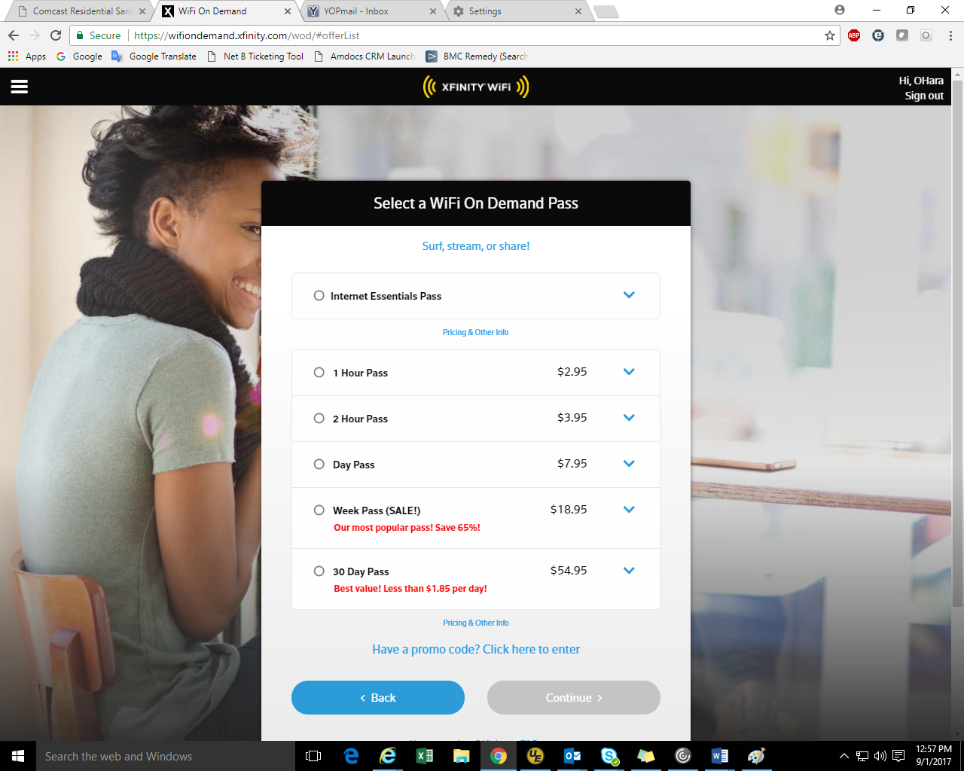

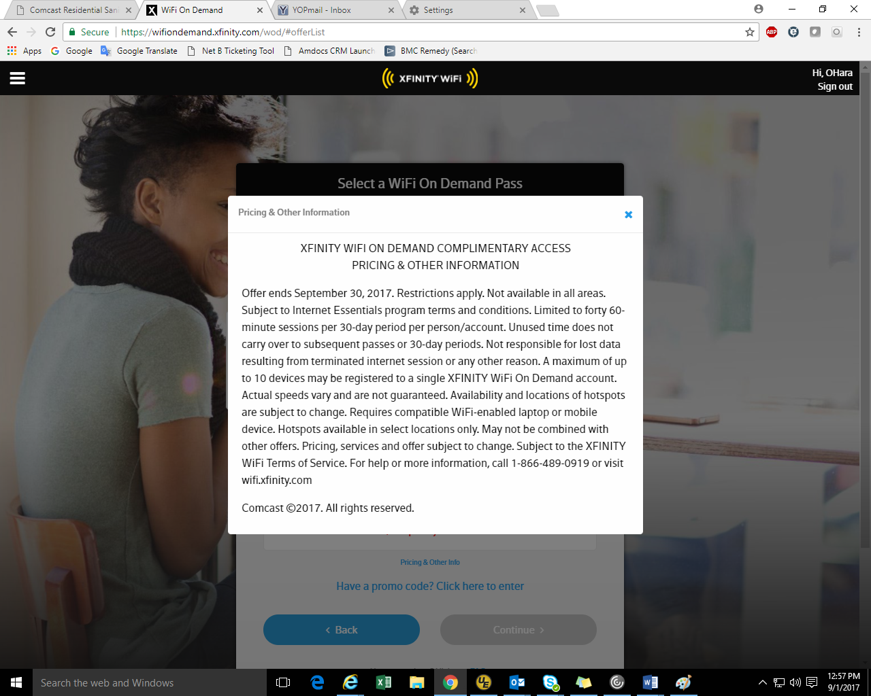

Prevent Users from Resubmitting Order Confirmation if Failure:

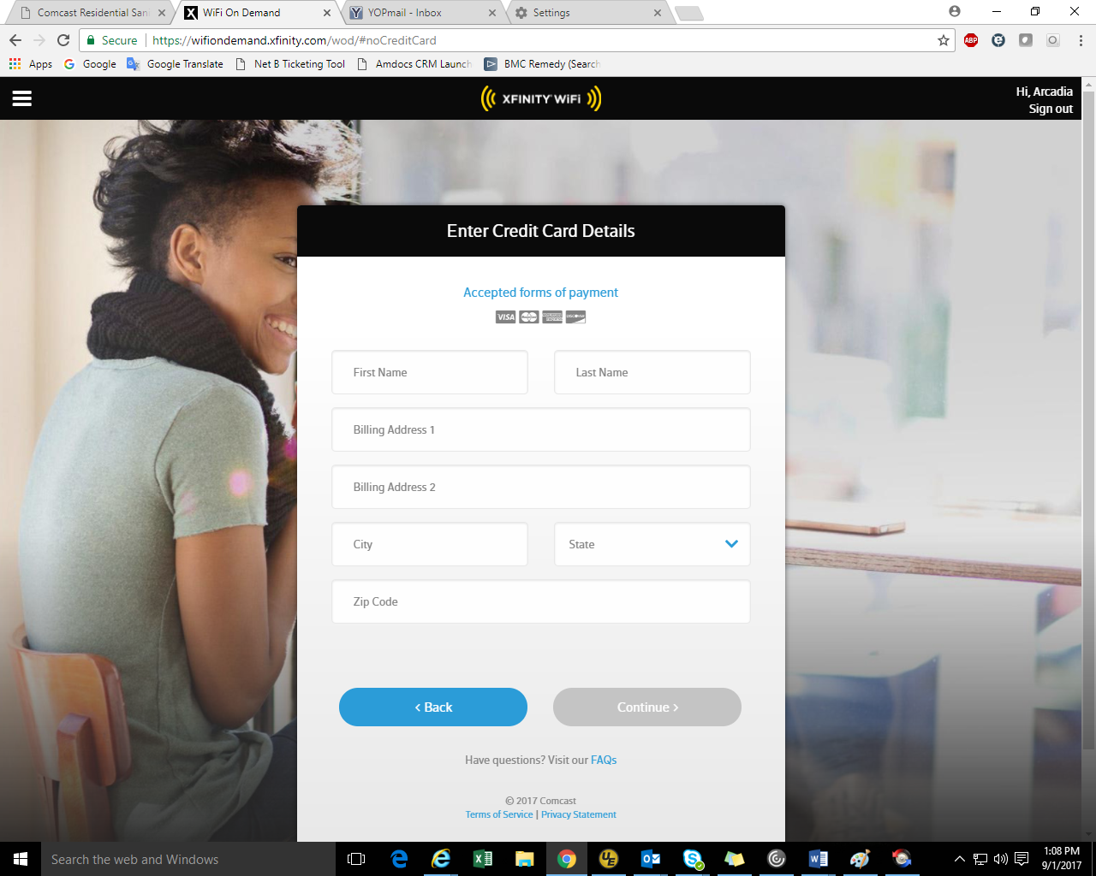

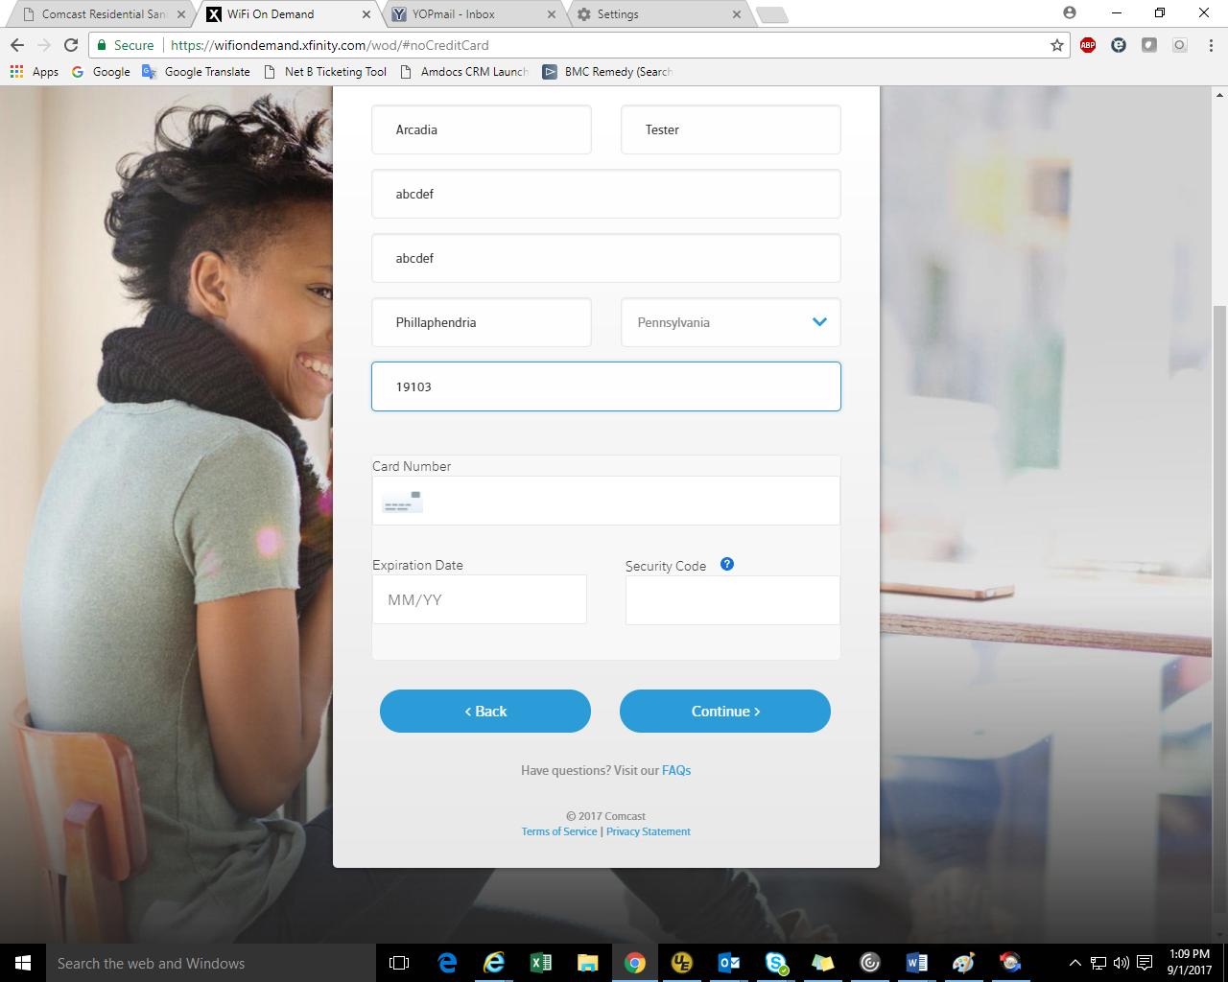

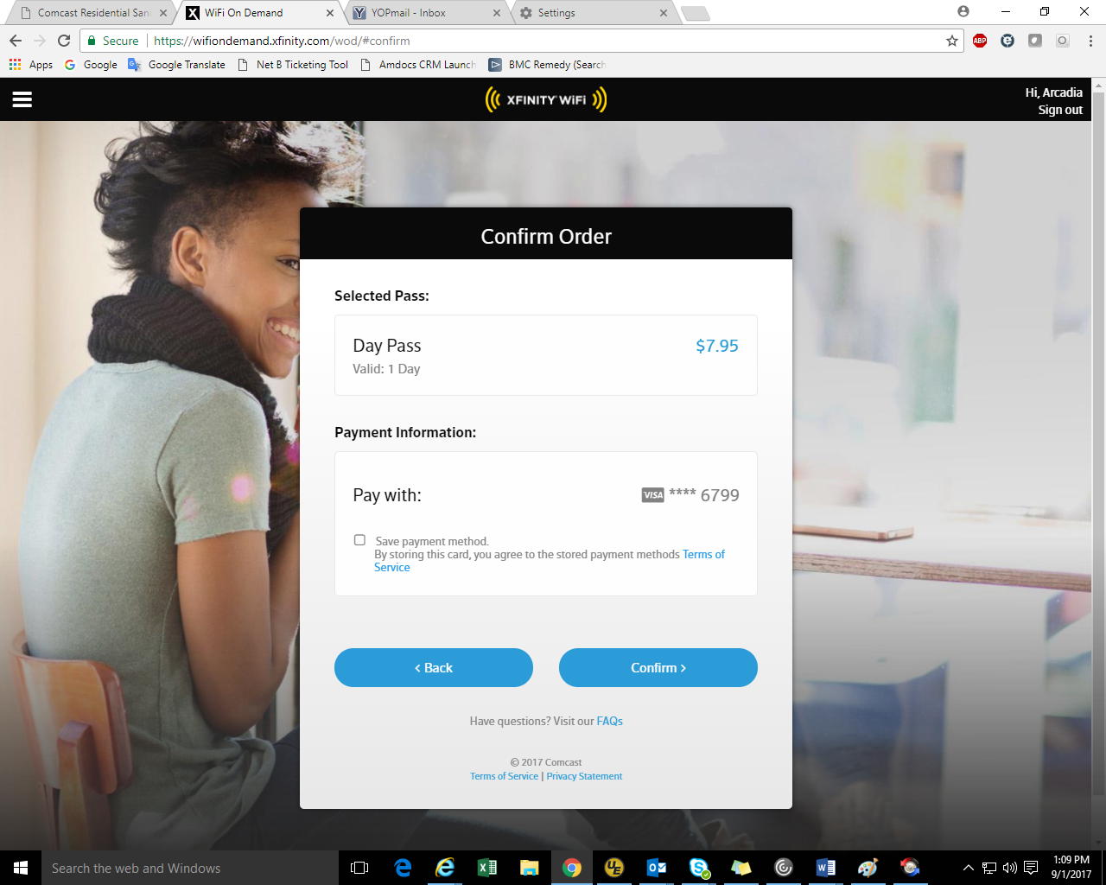

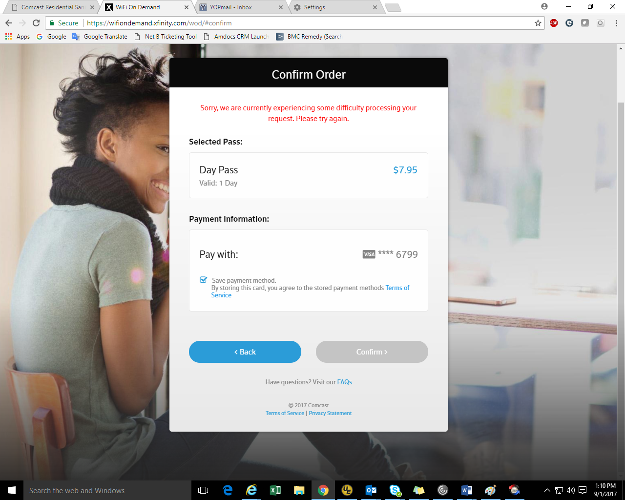

\*\*We can see that the after payment failure, we won’t be able to click on “Confirm” in order to resubmit.

Instant TV:

